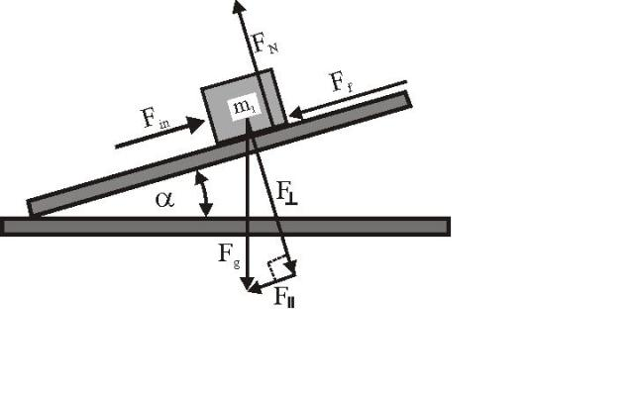Physics 11 – Spring 2013

Halifax West High School
Ms. Skelhorn, Mr. Lee
Room C340
Contact: SkelhornT@hrsb.ns.ca, ping.lee@dal.ca
Extra Help: Lunch, Monday**
Webpage: http://physicsworld11.weebly.com/

Topics

Kinematics – 25% (20 days)
- Study of linear motion as described by the variables, time, displacement, velocity and acceleration.
- Use of instruments and proper methods of obtaining reliable data to calculate the above.
- Sources of error and calculation of % error.
- Discussion and design of experiments that control variables.
- Displaying data graphically using position/time and velocity/time graphs and interpretation of these graphs.
- Best-fit lines for scatter data along with interpolation and extrapolation of data based on graph shape.
- Interpreting trends from graphs.
- Discussion of frames of reference for motion.
- Problem solving, analyzing word problems and solving algebraically using motion equations.

- ICA – 4
- Lab – 3
- Homework Probes – 4
- Tests – 14

Dynamics – 30% (25 days)
- Use of vectors to represent forces – algebraic and trigonometric solutions to problems.
- Discussion and use of Newton’s Laws as they apply to inertia, force mass, acceleration and interaction among forces.
- Examine friction and understand the difference between static and kinetic or moving friction.
- Understand coefficient of friction, normal force, distinguish between mass and weight.

- ICA – 5
- Lab – 3
- Homework Probes – 5
- Tests – 17

Momentum and Energy –30% (25 days)
- Discussion of momentum as it applies to impulse change, changes in momentum and one-dimensional collisions. Discussion of conservation of energy and momentum with respect to one-dimensional collisions and explosions.
- Relationship between force, distance, and work and how work is related to power and time.
- Machines, ideal and actual mechanical advantage, efficiency of machines.
- Potential, kinetic, and elastic potential energy. Relationship between force and extension; Hooke’s Law.

- ICA – 5
- Lab – 3
- Homework Probes – 5
- Tests – 17

Waves – 15% (16 days)
- Major components and properties of waves such as longitudinal and transverse, reflection, refraction, diffraction, pulse and period, interference.
- Use of wave equation for problem solving.
- Electromagnetic spectrum and the difference between electromagnetic waves and mechanic waves.
- Sound and its characteristics as applied to waves. Examination of the Doppler Effect.
- Relate properties of waves to light refraction and Snell’s Law.
- Use laws of reflection and refraction to explain the behavior and uses of lenses and mirrors.

- ICA – 2
- Lab – 3
- Homework Probes – 2
- Tests – 8

Important Information

Missed Days: If you miss a class you will need to find out what was covered that day, if you need to collect any materials, or get notes. The responsibility of getting missed materials is up to you. Check the website, call a friend, or ask the teacher.

Missed Tests/Quizzes: If you miss a test you will need to have a valid written excuse from a doctor or from your parent/guardian. You will be expected to write the test the first day you are back from school during lunch or another arranged time. No missed tests or quizzes will be written during regular class time.

Assignments: Students are responsible for completing assignments by specified due dates so that teachers can provide timely feedback. Assignments are due on the assigned day at the beginning of class. A due date is given for each assignment. If the student does not hand in the assignment on the due date, the student may consult with the teacher regarding a possible alternate due date. This must be done in a timely manner and this is the students’ responsibility to initiate. If the alternate due date is granted but not met, the student will have receive a zero. Furthermore, if the assignment has been marked and passed back, the student will not receive an opportunity to pass it in.

Classroom Expectations:
- Be on time for class and come prepared. Chronic lateness will not be tolerated.
- Students are permitted to have WATER ONLY in the classroom.
- IPods or MP3 players will be permitted only upon teacher’s instruction.

Contact Information: Email: SkelhornT@hrsb.ns.ca
Phone: 457-8900 extension 560-1327
Webpage: http://hrsbstaff.ednet.ns.ca/tskelhorn/

Student’s progress and attendance are available through POWERSCHOOL. Parents and students are encouraged to stay up to date. Please feel free to contact me anytime by email.

**Note: Effective until April 12, 2013. After that date, extra help sessions will be held at Lunch on Tuesday. If necessary, extra time can be arranged with the teacher.

